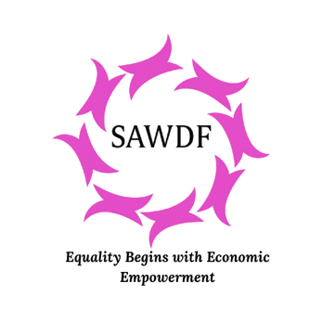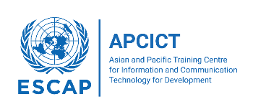

# **Empowering Women Entrepreneurs in Nepal through Digital Transformation**

# **19-21 August 2025, Kathmandu, Nepal**

Supporting women entrepreneurs, particularly those engaged in micro, small, and medium enterprises (MSMEs), in harnessing the potential of digital tools and platforms is of paramount importance. It is a crucial step towards gender equality in the entrepreneurial ecosystem. Women, despite their immense potential, often face systemic barriers and disparities in accessing resources and opportunities. Digital tools and platforms can level the playing field by providing them with accessible and cost-effective means to market their products, access financial services, and acquire the skills necessary to grow their businesses.

The integration of digital tools, platforms, and analytics into the business strategies of women entrepreneurs can lead to greater economic resilience and sustainability. Women-owned MSMEs are particularly vulnerable to external shocks, such as economic downturns or natural disasters. Digitalization, through e-commerce and digital marketing, enables the diversification of revenue streams by reaching new markets. Furthermore, digital tools and analytics improve inventory management, cost optimization, and customer engagement—factors critical to business survival and growth. Supporting women-led MSMEs in adopting digital solutions strengthens their capacity to navigate economic uncertainties, contributing to the overall stability and resilience of their businesses

The Asian and Pacific Training Centre for ICT for Development (APCICT), in collaboration with the South Asia Women Develoment Forum (SAWDF), is organizing the “***WIFI DX Training on Empowering Women Entrepreneurs through Digital Transformation***” on 19-21 August 2025 in Kathmandu, Nepal. The training aims to build the digital capacities of women entrepreneurs by enhancing their understanding and practical skills in areas such as e-commerce and digital marketing; trust and security in using digital technologies; and business continuity planning. Through this direct training, APCICT seeks to support women entrepreneurs in Nepal to successfully navigate the digital economy and unlock new opportunities for business growth.

# **About the Programme**

The programme is based on APCICT’s Women ICT Frontier Initiative (WIFI), a capacity building programme for women entrepreneurs to utilize digital tools, platforms and analytics in their businesses. The 3-day training will include the following modules:

* E-Commerce and Digital Marketing. This module equips women entrepreneurs with the practical skills needed to establish online presence and effectively market their products or services in the digital space.
* Trust and Security in using Digital Technologies. This module imparts women entrepreneurs with fundamental skills concerning online security. It is dedicated to enhancing their basic skills and increasing awareness regarding digital security and data privacy.
* Business Continuity Planning. This module addresses the need for proactive planning in the face of uncertainties. Business continuity planning will provide knowledge and skills for women entrepreneurs to plan, strategize, and manage crisis situations in their businesses.

**DRAFT PROGRAMME**

|  |  |
| --- | --- |
| Tuesday, 19 August 2025 | |
| Time | Description |
| 8:00 – 9:00 | Registration |
| 9:00 - 9:30 | **Opening Session**   * Welcome Remarks   + APCICT, SAWDF, Gov’t of Nepal * Group Photo |
| 9:30 – 10:30 | **Module 1: Digital Marketing & E-Commerce**  This session introduces practical skills needed to establish online presence and effectively market their products or services in the digital space. By mastering e-commerce platforms and digital marketing strategies, women entrepreneurs can tap into global markets, reach a wider audience, and boost sales, thereby expanding their businesses beyond geographical boundaries. |
| 10:30 – 10:45 | *Coffee Break* |
| 10:45 – 12:30 | **Module 1 continued** |
| 12:30 – 2:00 | *Lunch* |
| 2:00 – 3:30 | **Module 1 continued** |
| 3:30 – 3:45 | *Coffee Break* |
| 3:45 – 5:30 | **Module 1 continued** |

|  |  |
| --- | --- |
| Wednesday, 20 August 2025 | |
| Time | Description |
| 9:00 – 10:30 | **Module 1 continued** |
| 10:30 – 10:45 | *Coffee Break* |
| 10:45 – 12:30 | **Module 1 continued** |
| 12:30 – 2:00 | *Lunch* |
| 2:00 – 3:30 | **Module 2: Trust and Security in Using Digital Technologies**  This module imparts women entrepreneurs with fundamental skills concerning online security. It aims to strengthen their foundational skills while raising awareness about digital security and the importance of protecting personal and business data. |
| 3:30 – 3:45 | *Coffee Break* |
| 3:45 – 5:30 | **Module 2 continued** |

|  |  |
| --- | --- |
| Thursday, 21 August 2025 | |
| Time | Description |
| 9:00 – 10:30 | **Module 2 continued** |
| 10:30 – 10:45 | *Coffee Break* |
| 10:45 – 12:30 | **Module 3: Business Continuity Planning**  This module emphasizes the importance of being prepared for unexpected challenges. It equips women entrepreneurs with the knowledge and skills to develop strategies, make informed plans, and effectively manage crises to ensure the resilience of their businesses. |
| 12:30 – 2:00 | *Lunch* |
| 2:00 – 3:30 | **Module 3 continued** |
| 3:30 – 3:45 | *Coffee Break* |
| 3:45 – 5:30 | **Module 3 continued**  **Evaluation, Certificates and Closing** |