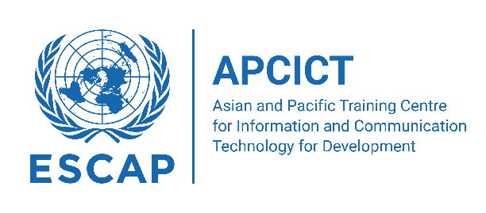

# **Cambodia National Training on Inclusive Digital Development and Data-Driven Governance**

# *31 October to 2 November 2023, Phnom Penh, Cambodia*

The **Cambodia Academy of Digital Technology** and the **Asian and Pacific Training Centre for ICT for Development** (APCICT/ESCAP) is organizing the **National Training on Inclusive Digital Development and Data-Driven Governance** in Phnom Penh on 3-5 October 2023.

The event, which will be attended by high-level officials across the country’s various ministries and agencies, aims to deepen appreciation of the concept of inclusive digital development and identify policies and programmes to realize an inclusive digital development strategy. It will highlight the social consequences of the data revolution and explore policy and other issues related to developing and implementing data-driven governance. The training will also look into the role of social media in governance and discuss its implication for national policy and programme formulation.

By the end of the training, participants will:

* Appreciate the concept of inclusive digital development and its importance in policymaking;
* Gain deeper understanding of the growing pervasiveness of digital technologies in our public and private spheres and how the adoption of these technologies can impact governance;
* Examine data-driven governance through a discussion of data-driven decisions, evidence-based policy, and results-based management; appreciate the role of data governance, data management, and data analytics;
* Explore policy and other issues related to developing and implementing data-driven governance; and
* Understand the role of social media in governance and its implication for policy formulation.

# **RESOURCE PERSONS**

* Mr. Emmanuel C. Lallana, PhD, Chief Executive, Ideacorp
* Mr. Faheem Hussain, PhD, Assistant Professor, School for the Future of Innovation in Society, Program Chair, MS in Global Technology & Development, College of Global Futures, Arizona State University

# **PARTICIPANTS**

* The event will be attended by high-level officials from ministries and agencies of Cambodia.

# **CONTACT**

* Mr. Robert de Jesus, Programme Officer, APCICT/ESCAP, [dejesus3@un.org](mailto:dejesus3@un.org)

# **PROGRAMME AGENDA**

|  |  |
| --- | --- |
| Day 1 – Tuesday (3 October) | |
| Time | Description |
| 09:00 – 09:30 | **Opening Session** |
| 09:30 – 10:00 | **Introduction: From ICT4D to Digital Development** |
| 10:00 – 10:30 | *Coffee Break* |
| 10:30 – 12:00 | **An Overview of ICTs and Sustainable Development** |
| 12:00 – 13:00 | *Lunch* |
| 13:00 – 14:30 | **Inclusive Digital Development: Session 1 – Digital Society** |
| 14:30 – 15:00 | *Coffee Break* |
| 15:00 – 16:30 | **Inclusive Digital Development: Session 2 – Digital Economy**   * Platform Economy * Platform Workers |

|  |  |
| --- | --- |
| Day 2 – Wednesday (4 October) | |
| Time | Description |
| 09:00 – 09:30 | **Review of Day 1** |
| 09:30 – 10:30 | **Inclusive Digital Development: Session 3 – Digital Politics**   * eParticipation * Digital Government |
| 10:30 – 11:00 | *Coffee Break* |
| 11:00 – 12:00 | **Inclusive Digital Development: Session 4 – Achieving Inclusive Digital Development** |
| 12:00 – 13:00 | *Lunch* |
| 13:00 – 14:30 | **Realizing Data Driven Governance: Session 1 – Data Driven Decision Making** |
| 14:30 – 15:00 | *Coffee Break* |
| 15:00 – 16:30 | **Realizing Data Driven Governance: Session 2 – Data Sources** |

|  |  |
| --- | --- |
| Day 3 – Thursday (5 October) | |
| Time | Description |
| 09:00 – 09:30 | **Review of Day 2** |
| 09:30 – 10:30 | **Realizing Data Driven Governance: Session 3 – Data Governance and Management** |
| 10:30 – 11:00 | *Coffee Break* |
| 11:00 – 12:00 | **Realizing Data Driven Governance: Session 4 – Data Analytics** |
| 12:00 – 13:00 | *Lunch* |
| 13:00 – 14:30 | **Social Media, Development and Governance: Session 1 – SocMed for Development** |
| 14:30 – 15:00 | *Coffee Break* |
| 15:00 – 16:30 | **Social Media, Development and Governance: Session 2 – SocMed for Governance** |
| 16:30 – 17:00 | **Closing and Evaluation** |