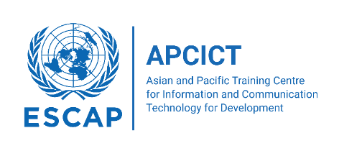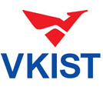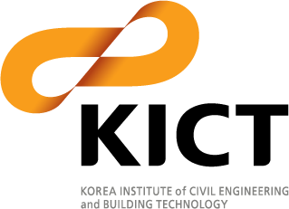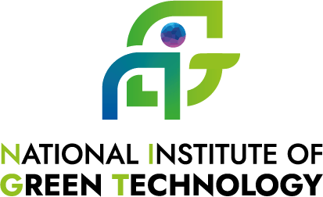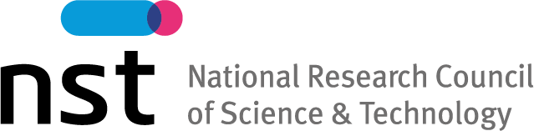

**South-East Asia Subregional Workshop** **on Green and Secure Smart City Development**

# *6-9 December 2023, VKIST in Hoa Lac, Viet Nam*

Climate change is a pressing environmental challenge, and the future of our planet depends on concerted action to reduce greenhouse gas emission. As the Asia-Pacific region is the most vulnerable to impacts of climate change, South-East Asia countries are engaged in ambitious urban planning endeavors and creating new cities with green and smart technologies. In increasing reliance on technologies, countries are also becoming more vulnerable to various forms of information system attacks, including cyber intrusions, cyber-terrorism, and cybercrime. Therefore, city planning needs to emphasize green, secure and smart development in all countries.

Recognizing the above, the National research council of Science and Technology (NST), the National Institute of Green Technology (NIGT), the Korea Institute of Civil Engineering and Building Technology (KICT), the Asian and Pacific Training Centre for Information and Communication Technology for Development (APCICT), and other Korean Government-funded Research Institutes (GRIs) are organizing the South-East Asia Subregional Workshop on Green and Secure Smart City Development on 6 to 9 December 2023 in VKIST, Hoa Lac, Viet Nam.

The meeting aims to:

* Enhance understanding among participants on green and secure smart cities;
* Build capacities information security and privacy, climate change technologies and smart city technologies;
* Exchange experiences and lessons learnt on green and secure smart cities; and
* Develop technology-related business/strategy/policy proposals for green and secure smart city development.

**PARTICIPANTS**

Government officials and experts from private sectors who are engaged in policies, projects or businesses on green and secure smart development in Southeast Asia countries.

**ABOUT THE ORGANIZERS**

* **Asian and Pacific Training Centre for Information and Communication Technology for Development (APCICT)**, a regional institute of the United Nations Economic and Social Commission for Asia and the Pacific (ESCAP), has developed capacity programmes on information security and privacy, ICT for climate resilient and development in “Academy of ICT Essentials for Government Leaders”.
* **National research council of Science and Technology (NST),** a national scientific and technological organization, providing policy support for national research projects and driving the development of knowledge industries by supporting, fostering, and systematically managing Korean GRIs in the field of science and technology. With 25 GRIs as members, NST has the function to support the globalization of GRIs and has built an international cooperation network on behalf of the group. NST stimulates convergence research between GRIs, plans GRIs’ development direction, assists in enhancing research performance and disseminating results, and resolves common difficulties faced by GRIs.
* **National Institute of Green Technology (NIGT)**, a member research institute of NST funded by the government of Republic of Korea, is established to respond to climate crisis and contribute to green growth, through the support for national green technology policies and global technology cooperation.
* **Korea Institute of Civil Engineering and Building Technology (KICT)**, as a GRI, is established to contribute to the development of national construction industry, improve quality of life standards, further national economic growth and improve social welfare.
* **Vietnam – Korea Institute of Science and Technology (VKIST)**, a new public agency on science and technology under the Vietnamese Ministry of Science and Technology. VKIST focuses on applied scientific research and the development of multi-disciplinary advanced technologies pertaining to industry and sustainable economic advancements.

**DRAFT PROGRAMME**

|  |  |  |  |  |
| --- | --- | --- | --- | --- |
|  | | | | |
| **Day 1** | | Moderator: Dr. OOO, VKIST | | |
| **Time** | | **Details** | | |
| 09:00-09:15 | | **Introduction of Program and Participants** | | |
| 09:15-11:00 | | **Lecture 1** | **Dr. Seunghyun Jung**, Principal Researcher, KICT  Smart Green City and Climate Technology | |
| 11:00-12:15 | | **Lecture 2** | **Mr. Moon-Sik Bae**, CEO, CarbonS  Green infrastructure development project applying blockchain technology | |
| 12:15-13:30 | | **Lunch** | | |
| 13:30-15:15 | | **Lecture 3** | **Dr. Minju Kim**, Chief Researcher, KICT  Smart Technology for Urban Resilience | |
| 15:15-17:00 | | **Lecture 4** | **Dr. Cheol-Ho Park**, Principal Researcher, KIER  Green energy technology demonstration for smart city | |
| 17:00-17:45 | | **Lecture 5** | **Mr. Brian Kim**, CEO, KIM Venturous  IR Strategy of Climate Technology Firm | |
| 17:45-18:30 | | **Dinner** | | |
|  | | | | |
| **Day 2** | Moderator: Dr. OOO, VKIST | | | |
| **Time** | **Details** | | | |
| 09:00-09:05 | **Opening Ceremony** | | | |
| 09:05-09:40 | **Opening Address** | | | **Dr. Byung-suk Kim**, President, KICT |
| **Congratulatory Address** | | | **Dr. Sang-hyup Kim**, Co-chairperson,  Presidential Commission on Carbon Neutrality and Green Growth |
| **Congratulatory Address** | | | **Dr. In Hwan Lee**, Director General, NST |
| **Congratulatory Address** | | | **Dr. Kiyoung Ko**, Director/Head of Office, UN APCICT |
| **Welcome Address** | | | OOOO, Vice Minister, Ministry of Science and Technology of Vietnam |
| 09:40-10:10 | **Keynote Lecture 1** | | | **Dr. Sang-hyup Lee**, President, NIGT  Soft-power Strategy for the Korea-ASEAN Public Private Partnership in Green Technology |
| 10:10-10:40 | **Keynote Lecture 2** | | | **Dr. Vu Duc Loi**, President, V-KIST  The Role of V-KIST for Korea-Vietnam-ASEAN Cooperation in Science and Technology |
| 10:40-10:45 | **NIGT-VKIST MoU Signing Ceremony** | | | |
| 10:45-11:00 | **Break** | | | |
| 11:00-12:15 | **Lecture 6** | | | **Dr. YoungJoo Ko**, Principal Researcher, KRICT  Innovative Green Chemical Technologies for Reducing and Using Greenhouse Gases |
| 12:15-13:30 | **Lunch** | | | |
| 13:30-16:30 | **Lecture 7** | | | **Mr. Freddy Tan,** Managing Director, EPIC Cybersecurity  Information Security and Privacy for Green Smart City |
| 16:30-17:45 | **Lecture 8** | | | **Dr. Donmin Lee**, Senior Researcher, NIGT  Major Achievements of NIGT to Implement Smart City in Asia |
| 17:45-18:15 | **Lecture 9** | | | **Dr. Jaeryoung Song**, Senior Researcher, NIGT  Strategical Writing of Proposal for Global Commercialization of Climate Technology |
| 18:15-19:00 | **Dinner** | | | |

|  |  |  |
| --- | --- | --- |
|  | | |
| **Day 3** | Moderator: Dr. OOO, VKIST | |
| **Time** | **Details** | |
| 08:30-09:00 | **Team Work** | Introduction of Teamwork Guideline **(**Dr. Joonho Yeo, Researcher, NIGT) |
| 09:00-12:00 | **Team Work** | Group Discussion on Global Industrialization related to Climate Technology |
| 12:00-13:00 | **Lunch** | |
| 13:00-14:30 | **Team Work** | Group Work to Write the Global Industrialization Proposal related to Climate Technology |
| 14:30-15:00 | **Break** | |
| 15:00-16:30 | **Startup**  **IR Day** | Southeast Asia Startup (around 10 firms)  - Sponsor: Sopoong Ventures, Presidential Commission on Carbon Neutrality and Green Growth, etc. |
| 16:30-17:15 | **Presentation** | Proposal Presentation |
| 17:15-17:45 | **Lecture 10** | **Mr. Sangyeob Han,** CEO,Sopoong Ventures  Two Twist Cards, Climate Technology and Startup |
| 17:45-18:00 | **Award Ceremony** | Awards for Outstanding Teams  - Awarder: Dr. Sang-hyup Kim (the Co-chairperson of Presidential Commission on Carbon Neutrality and Green Growth), Dr. Byung-suk Kim (the President of KICT), Dr. Vu Duc Loi (the President of V-KIST), etc. |
| 18:00-18:15 | **Closing Address** | **Dr. Kiyoung Ko,** Director/Head of Office, UNAPCICT  **Dr. In Hwan Lee,** Director General, NST |
| 18:15-20:00 | **Dinner** | |

|  |  |
| --- | --- |
| **Day 4** |  |
| **Time** | **Details** |
| 09:00-10:30 | Wrap-up meeting |